1. Register at IPUMS using the following link;

<https://uma.pop.umn.edu/usa/user/new>

2. On [ipums.org](http://ipums.org), select IPUMS USA (<https://uma.pop.umn.edu/usa/user/new>) and then click on “Get Data”.

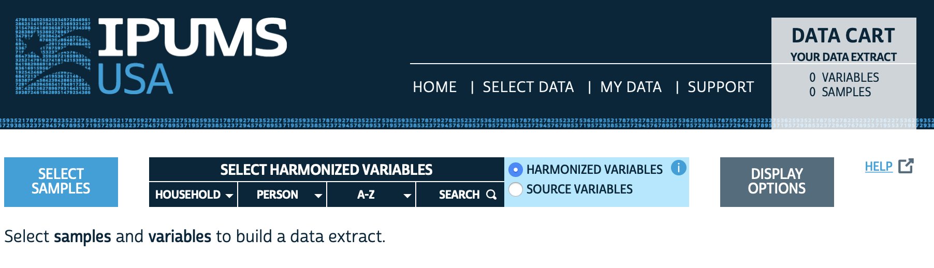

3. We first need to select a sample (i.e. the survey we want to use for the poststratification table) with a Manu that is opened by clicking on the SELECT SAMPLES button shown above. In our case, we we will select the 2018 5-year ACS survey and then click on SUBMIT SAMPLE SELECTION: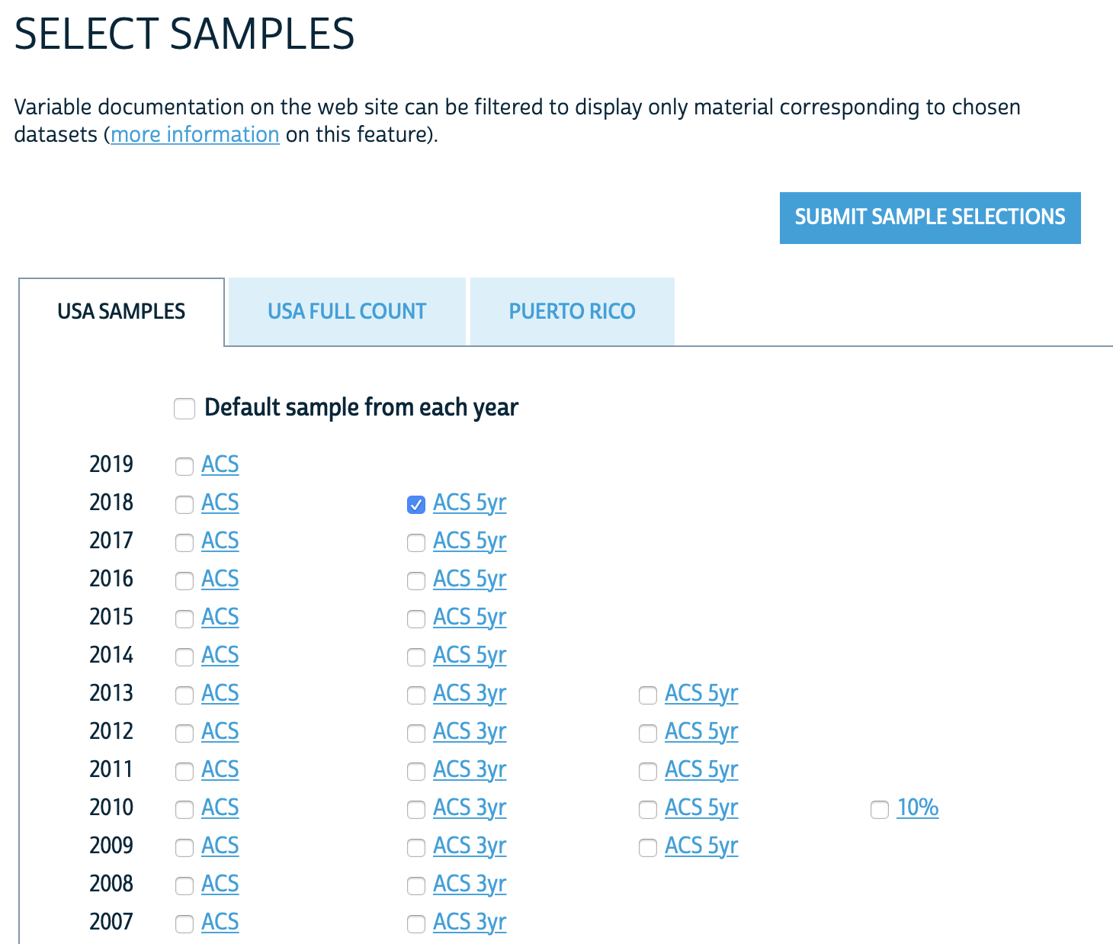

4. After selecting the sample we need to select the variables that will be included in our poststratification table. The multiple variables are conveniently categorized by HOUSEHOLD (household-level variables), PERSON (individual-level variables), and A-Z (alphabetically). For instance, clicking on PERSON > DEMOGRAPHIC displays the demographic variables, as shown below. Note that the rightmost column shows if that variable is available in the 2018 5-year ACS. Note that if you click on a certain variable IPUMS will provide a description and show the codes and frequencies. Based on the data available in your survey of interest, this is a useful tool to decide which variables to include in the poststratification table. For our poststratification table, we select:

* On PERSON > DEMOGRAPHIC select SEX and AGE
* On PERSON > RACE, ETHNICITY, AND NATIVITY select RACE and HISPAN
* On PERSON > EDUCATION select EDUC
* On HOUSEHOLD > GEOGRAPHIC select STATEFIP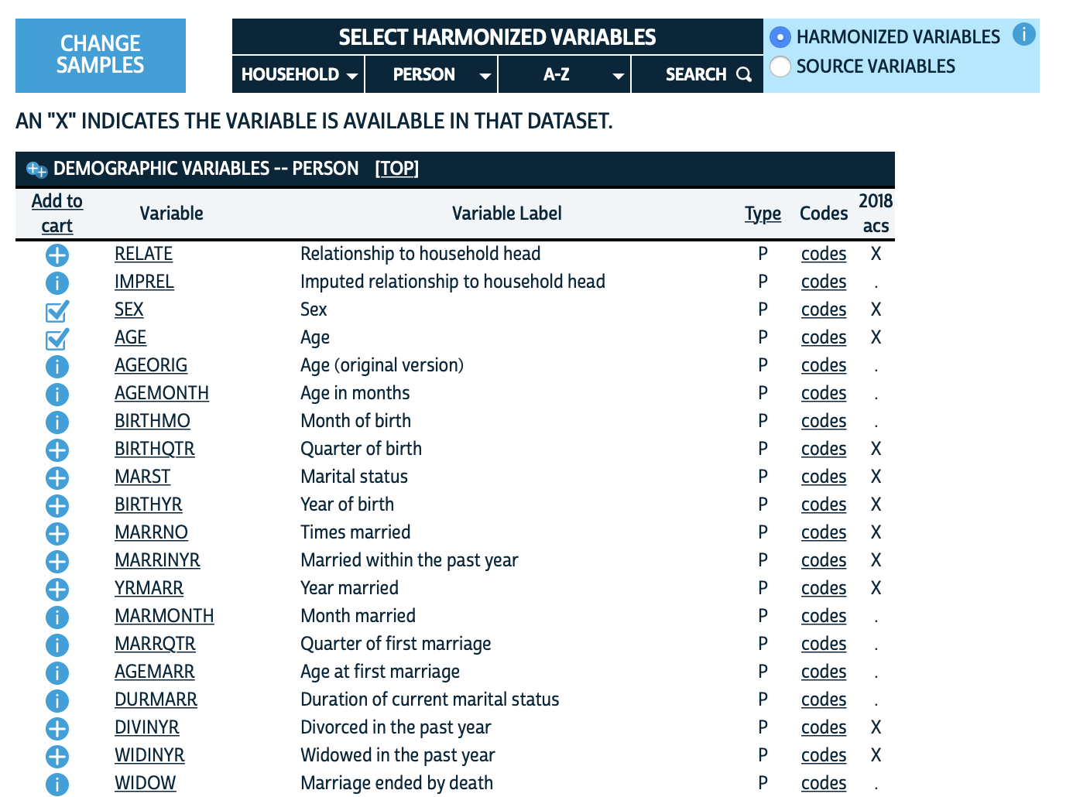

5. After selecting the variables we can review them by clicking on VIEW CART on the upper right corner.

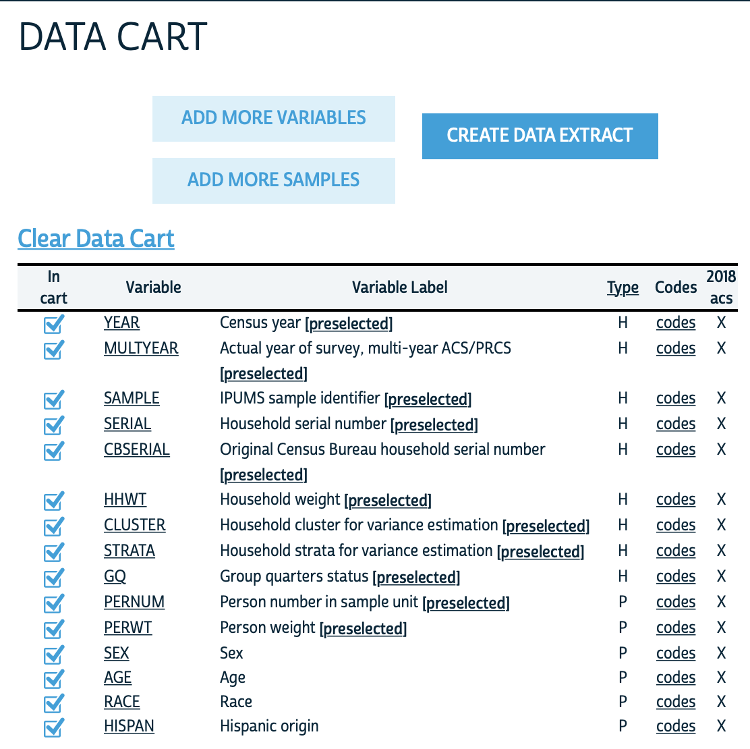

6. After reviewing these variables we click CREATE DATA EXTRACT. By default the data format is a .dat with fixed-width text, but we can change this by selecting a more frequently-used csv. After clicking SUBMIT EXTRACT the data will be generated. This can take a while, but you will receive an email when it’s ready.

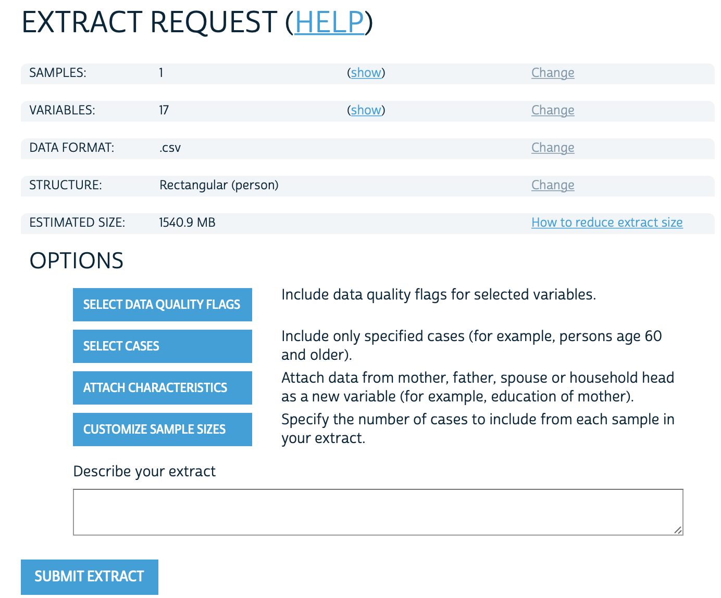

7. If you use IPUMS in your projects, don’t forget to cite it appropriately:

Steven Ruggles, Sarah Flood, Ronald Goeken, Josiah Grover, Erin Meyer, Jose Pacas and Matthew Sobek. IPUMS USA: Version 10.0 [dataset]. Minneapolis, MN: IPUMS, 2020. <https://doi.org/10.18128/D010.V10.0>